***Trail of People***

Historian(Ann): Image which represents yourself

Time-Keeper: Hanyu Chen

Navigator(Caroline Guo): Two Truths and One Lie

Facilitator (Luke Hong) : Trial of People - HomeTown Hero

Recorder(Mona): Trial of People - Night at the Movies

Recorder : ​​favorite movie with ur role

* Facilitator: Inception
  + https://www.youtube.com/watch?v=YoHD9XEInc0
* Time-keeper: August Rush

https://www.youtube.com/watch?v=zhpwjrbeoJQ

* Historian: Ocean’s 8
  + https://www.youtube.com/watch?v=MFWF9dU5Zc0
* Navigator: Interstellar <- <https://www.youtube.com/watch?v=3WzHXI5HizQ>
* Recorder : There will be blood
  + https://www.youtube.com/watch?v=FeSLPELpMeM

Historian**: image** on their phone that captures who they are and what they hope to contribute to the team. Then have each team member hold up their photo to the camera and explain its importance.

* Facilitator
* Navigator:
* Recorder: Good friend
* Historian

The Trials of the Facilitator: Who is famous from your hometown?

* Facilitator: Tobin Powell Heath
* Time-Keeper: Buddha
* Recorder : Li Bingbing
* Historian: Jolin Tsai
* Navigator: Liu Huan

Time-Keeper: Where are you From? Where are you Now? and Where are you Going? - Using pen and paper, draw three pictures that answer the three questions in the title

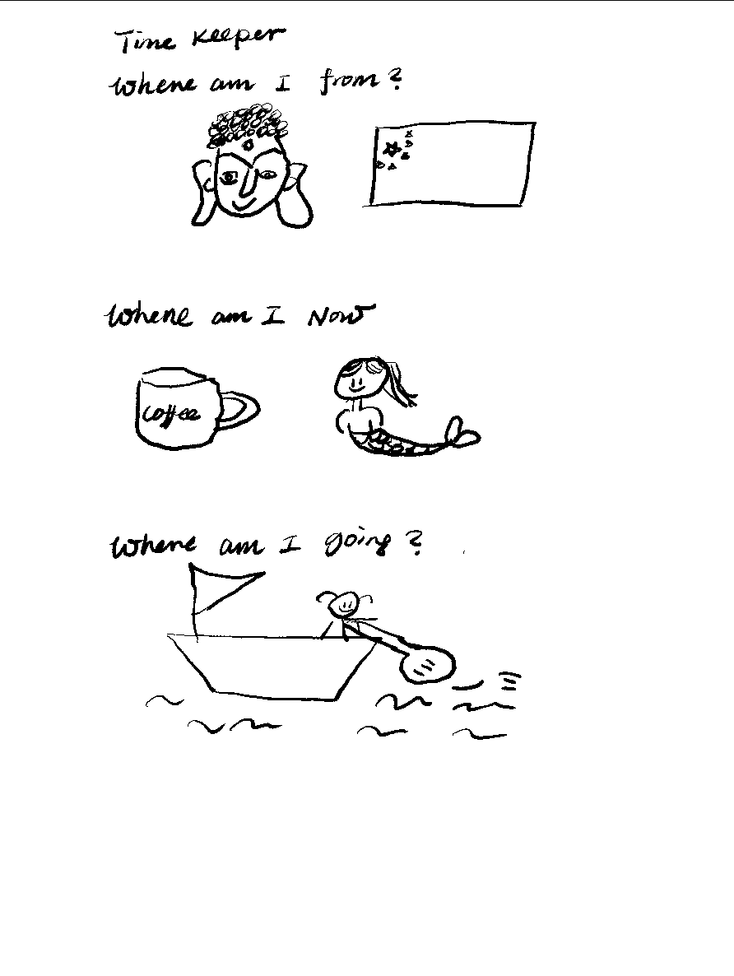

The Navigator's 3 answers:

1. Leshan, China
2. Starbucks near home
3. Classes lol

Historian’s 3 answers:

1. Leshan
2. Starbucks
3. Ocean

Facilitator:

* Leshan, China
* Starbucks
* Overseas

Record

* Leshan, China
* Starbucks
* oversea

***Trial of Place: Riddles***

Facilitator:

* When Ishmael faced a November of his soul,
* It was from this city where he hoped to become whole.
* Now a bare chested man with the tools of his trade,
* strikes out eternally in a flag pole's shade.
* Question: What phrase is carved in the stone behind him?
  + A DEAD WHALE OR A STOVE BOAT

Historian: What is the name of the establishment here that provides meals and a room for the night?

* Here Ilvermorny lies shrouded from sight,
* and Thoreau and Melville adored it's great heights.
* But in stone and slate rest can be found,
* for hikers from Georgia heading Maine bound.

Answer: BASCOM LODGE

Recorder:

Where John Proctor once lived and then fell,

Accused as a servant from hell.

Though the Puritans are gone,

Their legacy lives on,

Visit here if you now seek a spell.

If you stood at the location above, what popular attraction would be on your right? *

* Salem Witch Museum

Time-Keeper:

An emerald jewel of the "Bean",

Which in the spring is a must to be seen.

Where you'll lazily float,

With a swan on a boat,

But beware, the squirrels can be mean!

Question: What drug has its own monument in this place?

* ETHER

Navigator:

* As Boston has grown, made land from sea foam,
* as its population grew dense.
* Built to serve the nation, now recreation,
* for this Island that served as defense.

Question: Whose name is inscribed on the obelisk?

* Col. William Prescott

Joseph Warren

COLONEL WILLIAM PRESCOTT

Dr. Joseph Warren

DR. JOSEPH WARREN

DOCTOR JOSEPH WARREN

Architect:

SOLOMON WILLARD

Donald McKay

DONALD MCKAY

The members of the Bunker Hill Monument Association took 25 years to figure out what to inscribe on their monument; in the end, they decided not to put any words on the obelisk at all. Americans today might find this choice a strange one. The iconic war memorial of our time—the wall honoring the dead and missing in Vietnam—is an achingly long stream of names. But in 1848, five years after the monument’s dedication, the Bunker Hill Monument Association voted “that the great object for which the obelisk was erected on Bunker Hill is monumental, and not historical, and that it is not expedient that any record of names, dates, or events connected with the battle should be inscribed on it.”

**Trial of Pride**

Coordinates: N4a 20’ 57” W7b 0c’ 58”

Coordinates: Na2 20’ 57” Wb1 0c’ 58”

Coordinates: N42 20’ 5a” W71 05’ bc”

Coordinates: N4a 20’ 5b” W71 05’ c8”

Coordinates: N42 a0’ b7” W7c 05’ 58”

**N42 20’ 57’’ W71 05’ 58”**

[**https://latitude.to/lat/42.34917/lng/-71.09944**](https://latitude.to/lat/42.34917/lng/-71.09944)

